**RESEARCH PORTFOLIO**

**ONLINE COMPUTER AIDED INSTRUCTION FOR**

**PUBLIC PRESCHOOL**

**STUDENTS**

**BACHELOR OF SCIENCE IN INFORMATION TECHNOLOGY**

**AGARCIO, ANGELO P.**

**GREGORIO, MARK GILSON P.**

**JORDAN, JEYMAR L.**

**JUNE 2021**

**TABLE OF CONTENTS**

**I ACCOMPLISHED FORMS Page**

Research Topic Proposal 2

Advisorship Agreement 4

Adviser Acceptance 5

Parental Consent for Oral Defense 6

Adviser Endorsement for Oral Defense 9 Language Editor Acceptance 10 Conformity of Revisions 11

**II Communication Letters**

Letter of Agreement 12

**III Data Gathering Activities**

Meeting with the Client 13

**IV Oral Defense**

Photograph and Narrative 14

**I ACCOMPLISHED FORMS**

Research Topic Proposal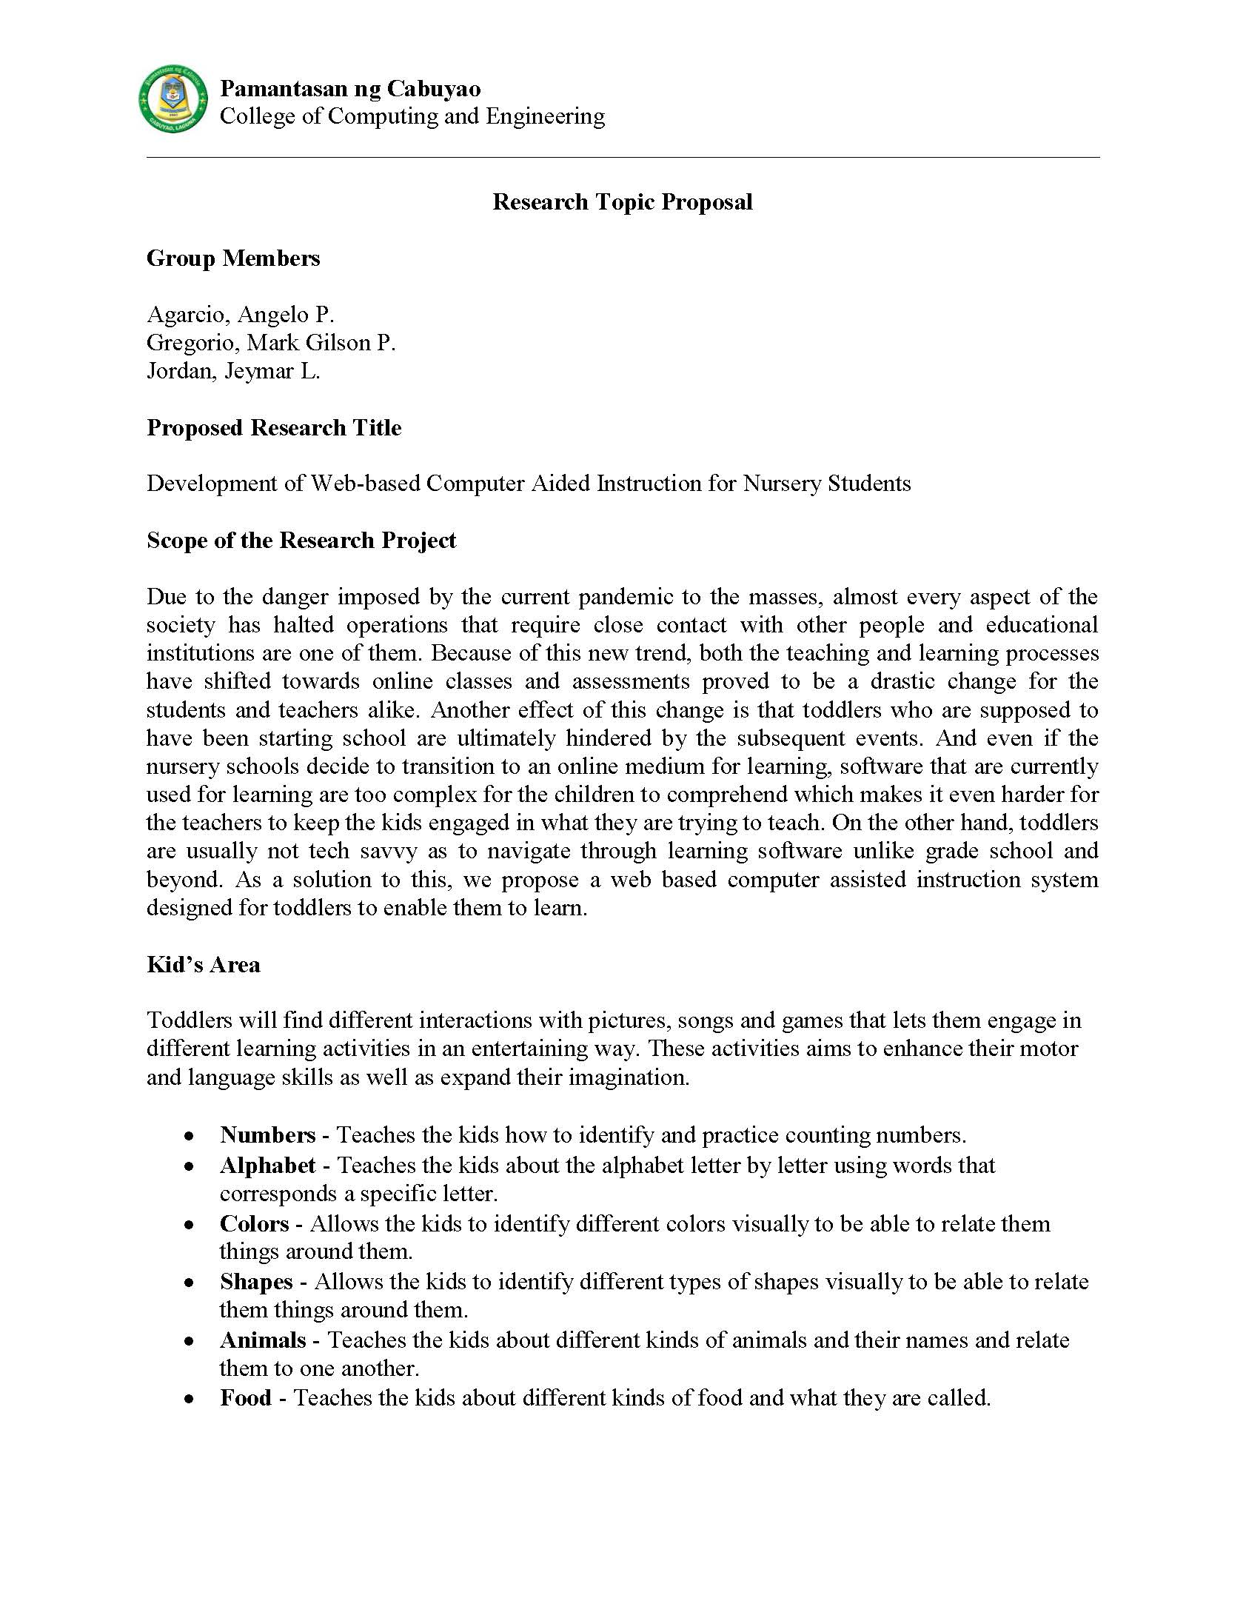

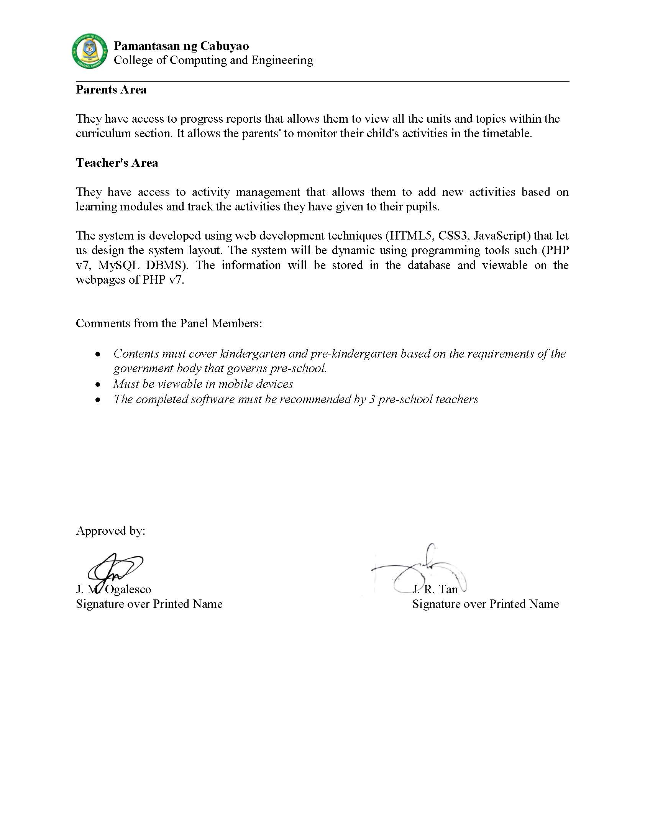

Advisorship Agreement

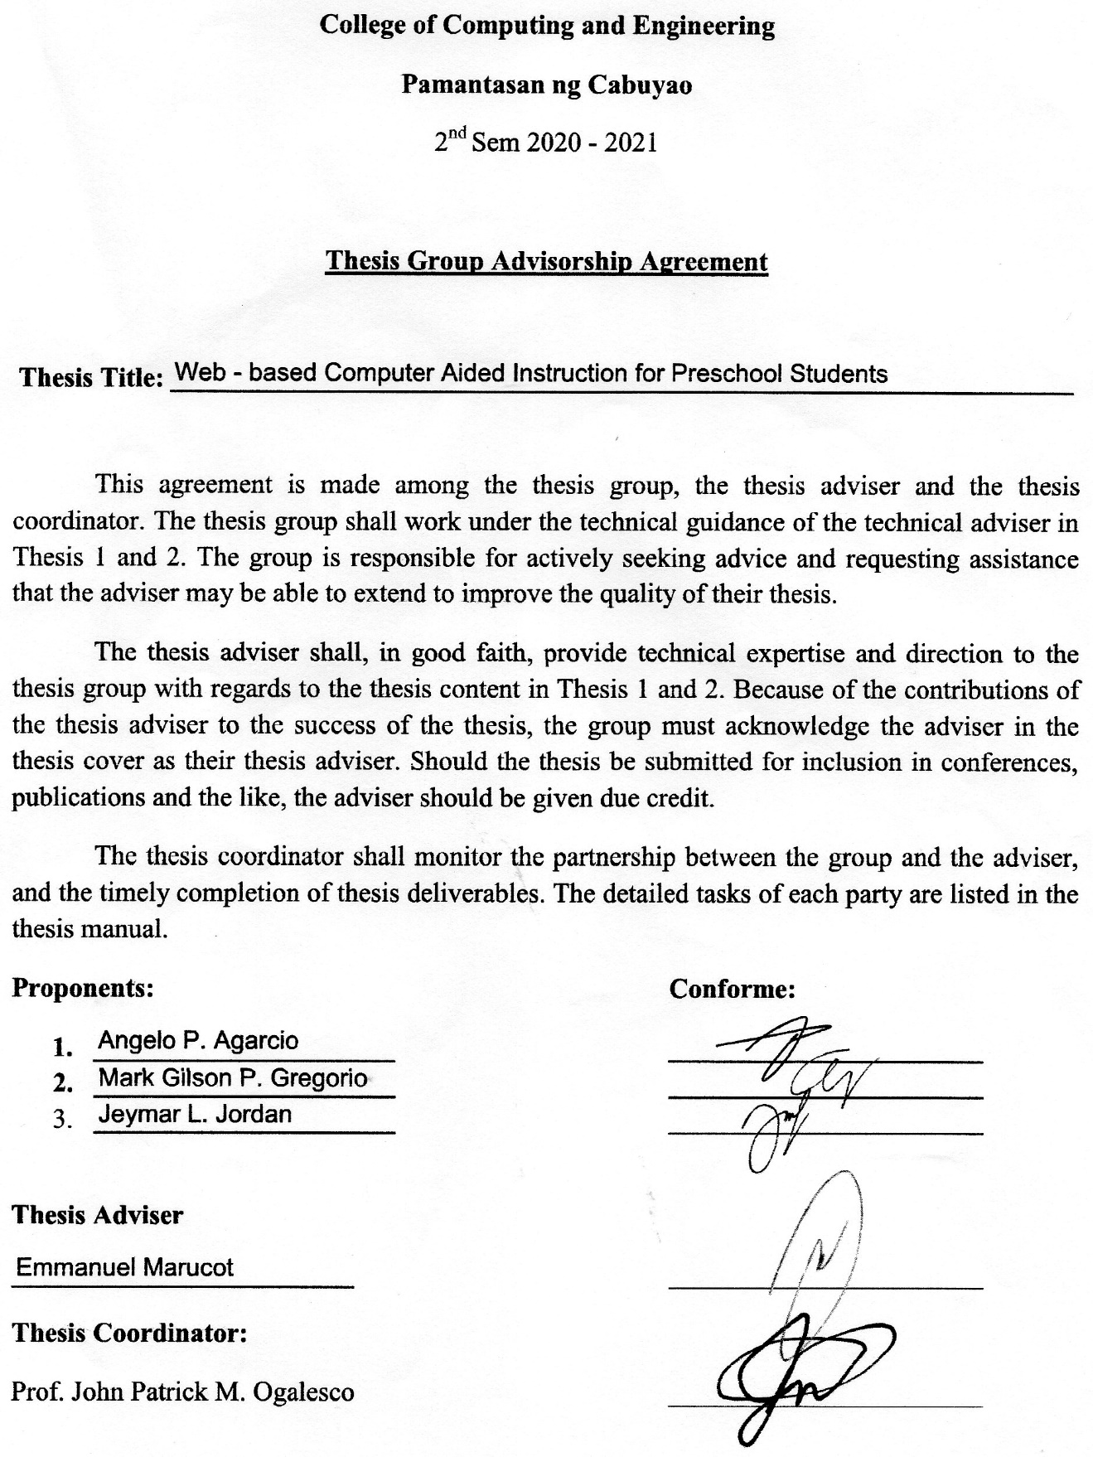

Adviser Acceptance

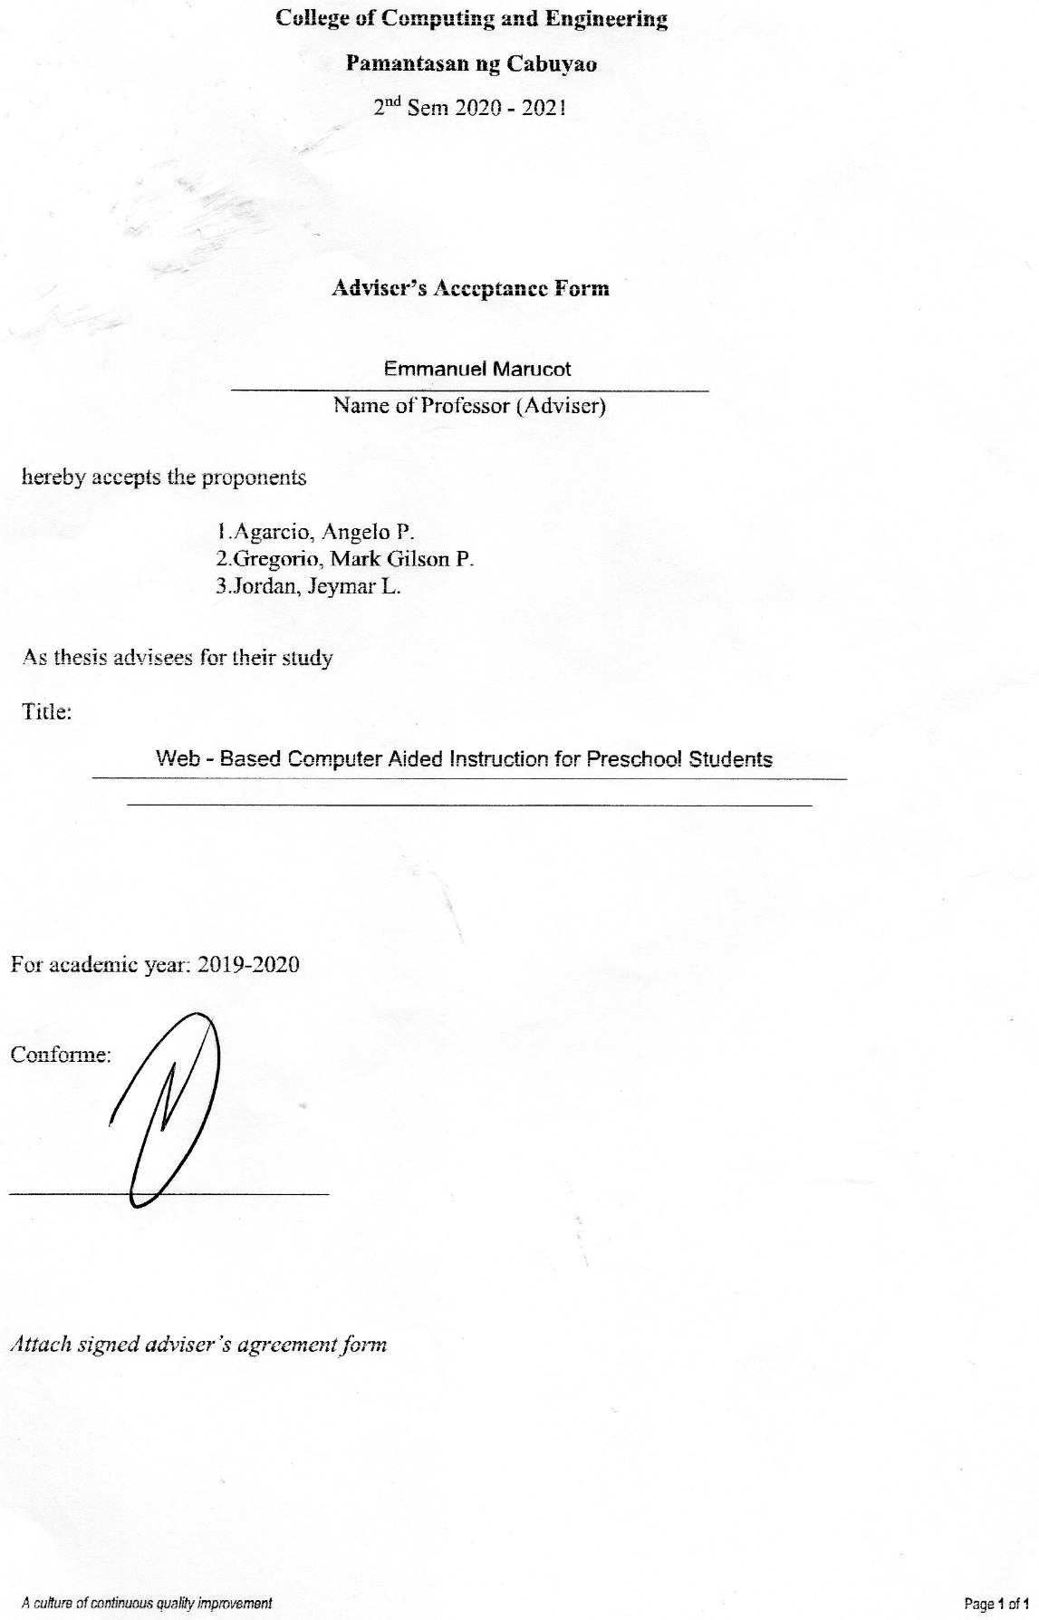

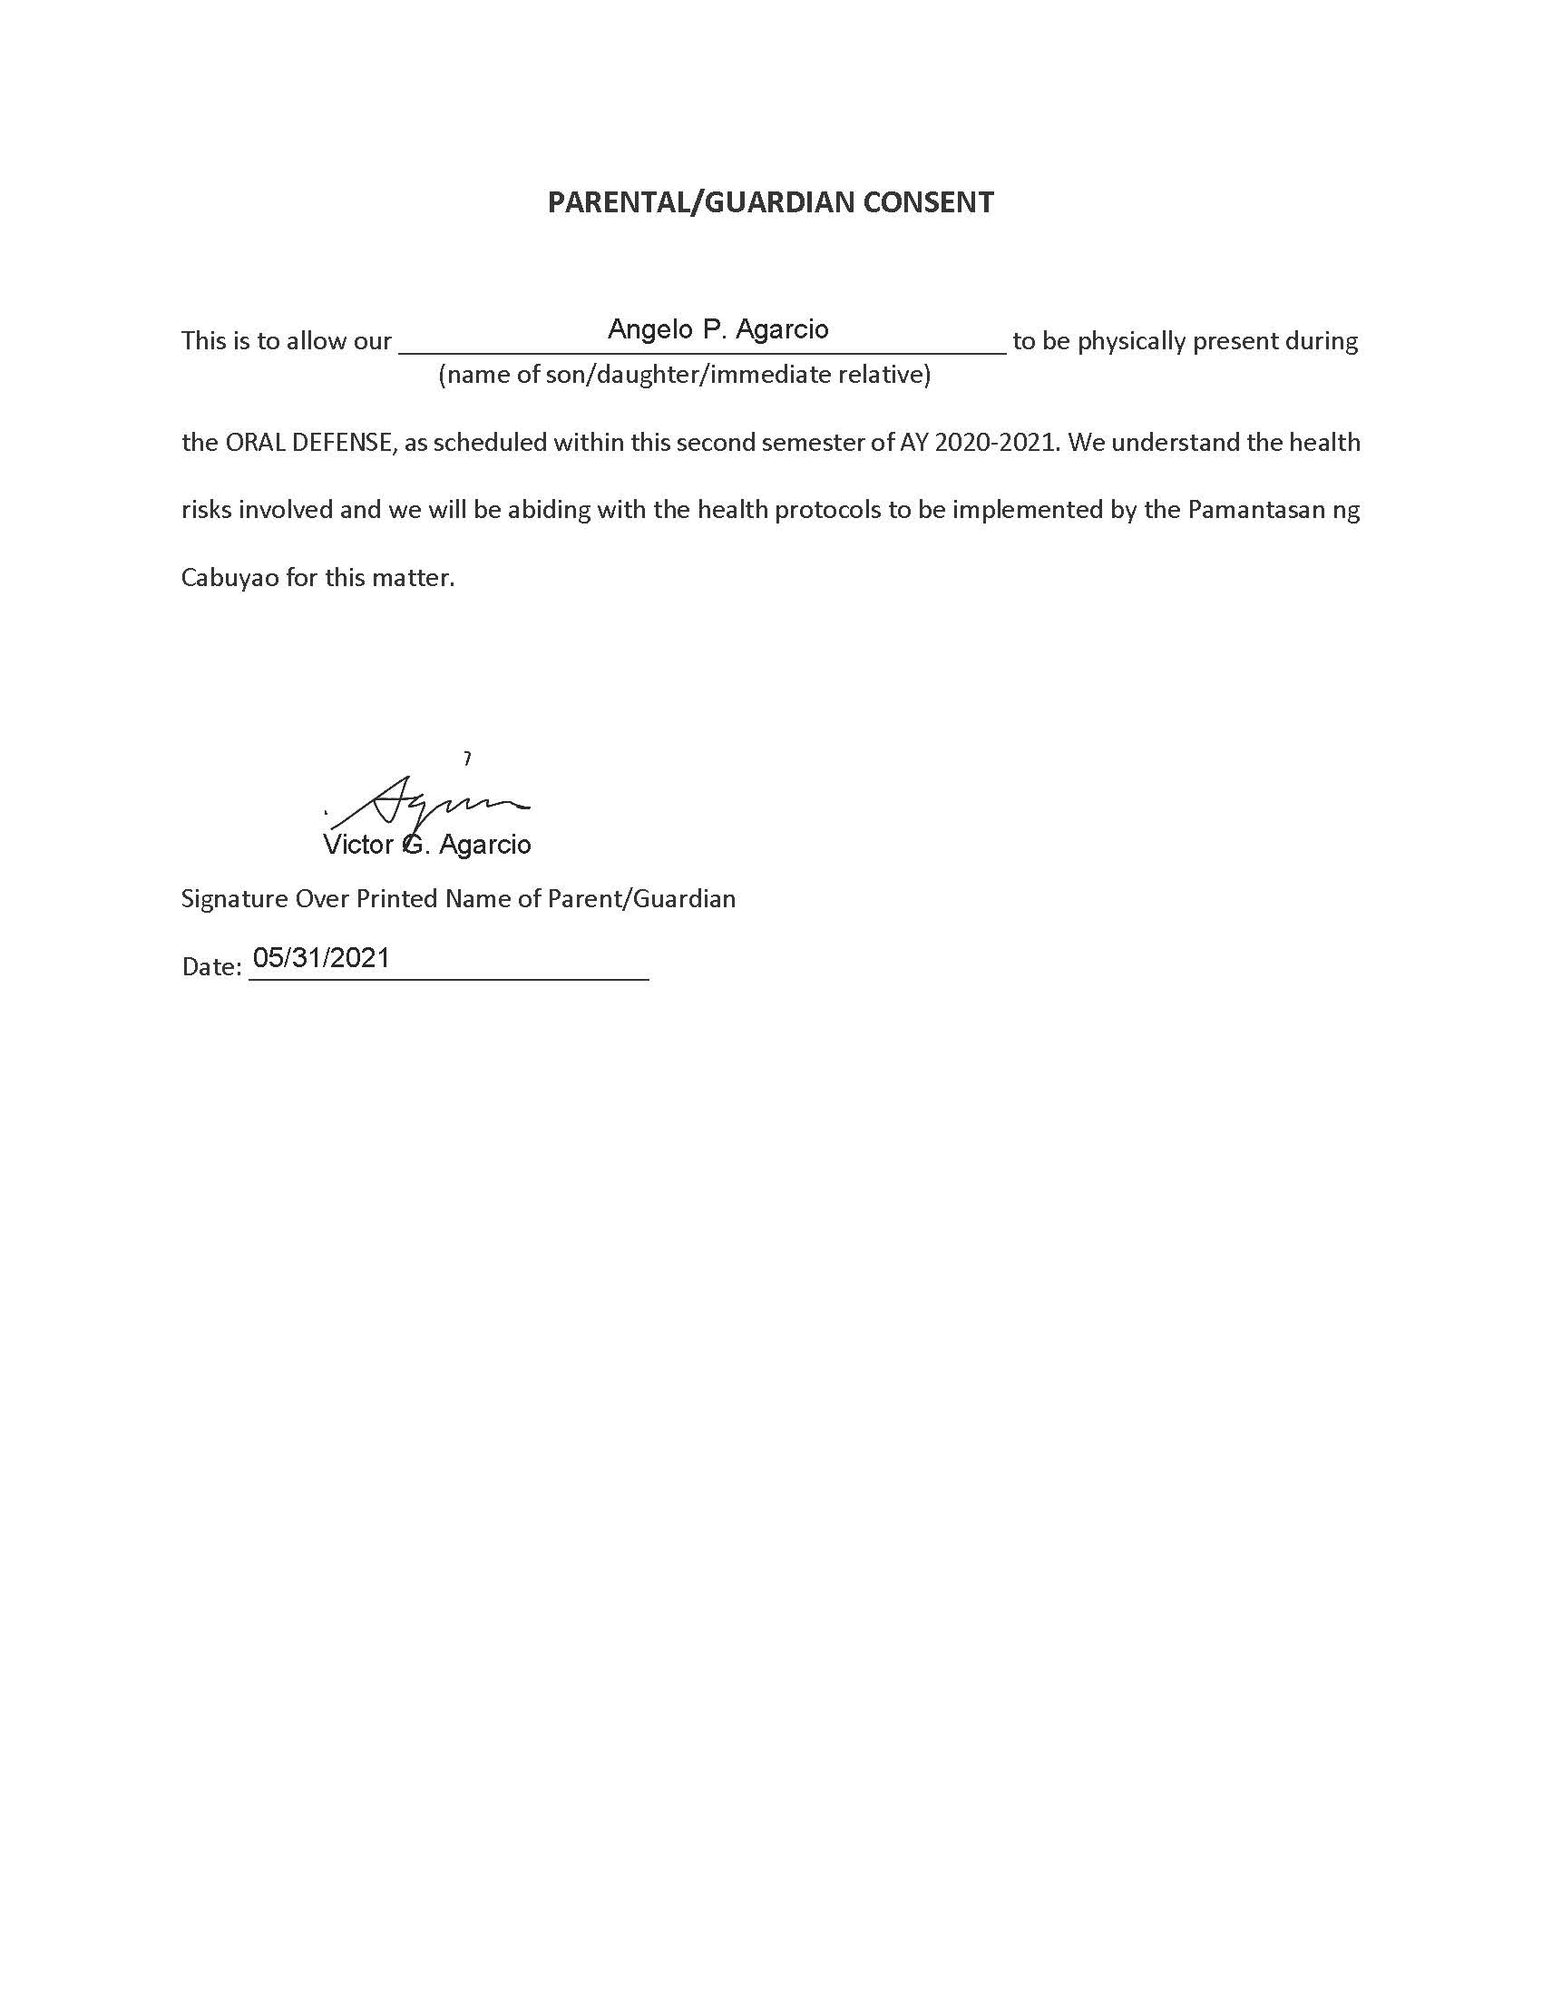Parental Consent for Oral Defense

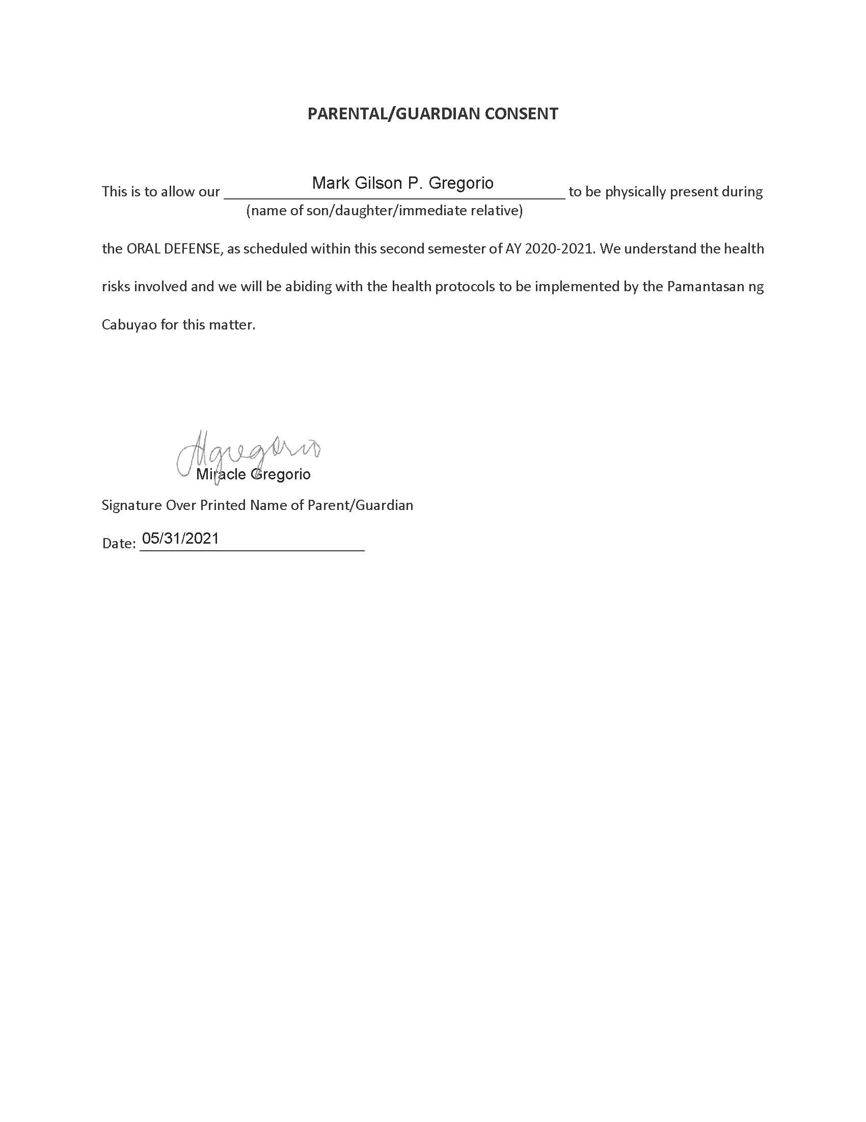

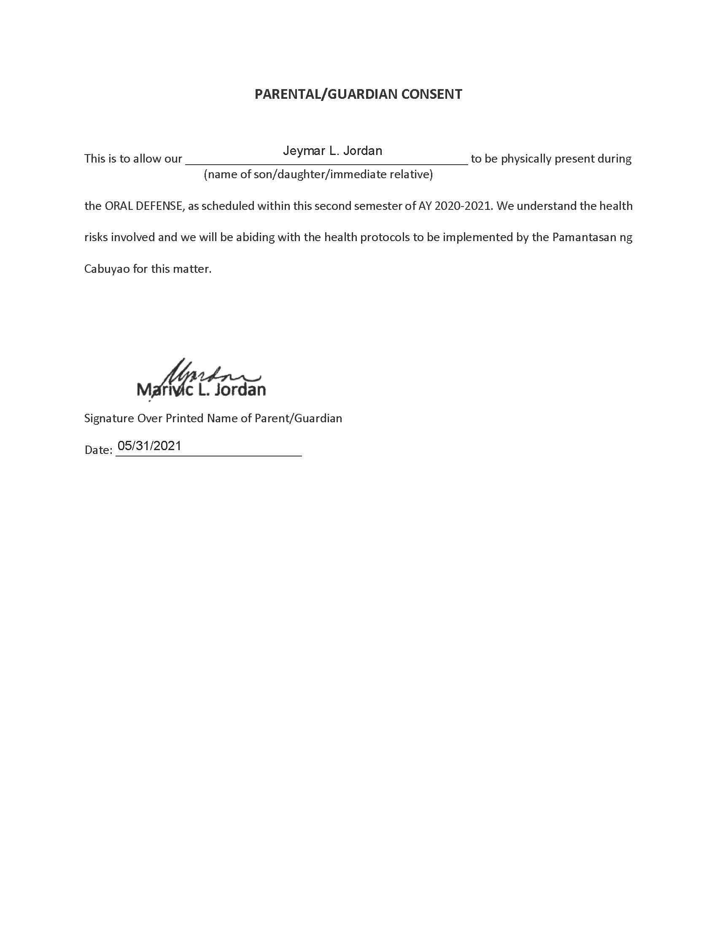

Adviser Endorsement for Oral Defense

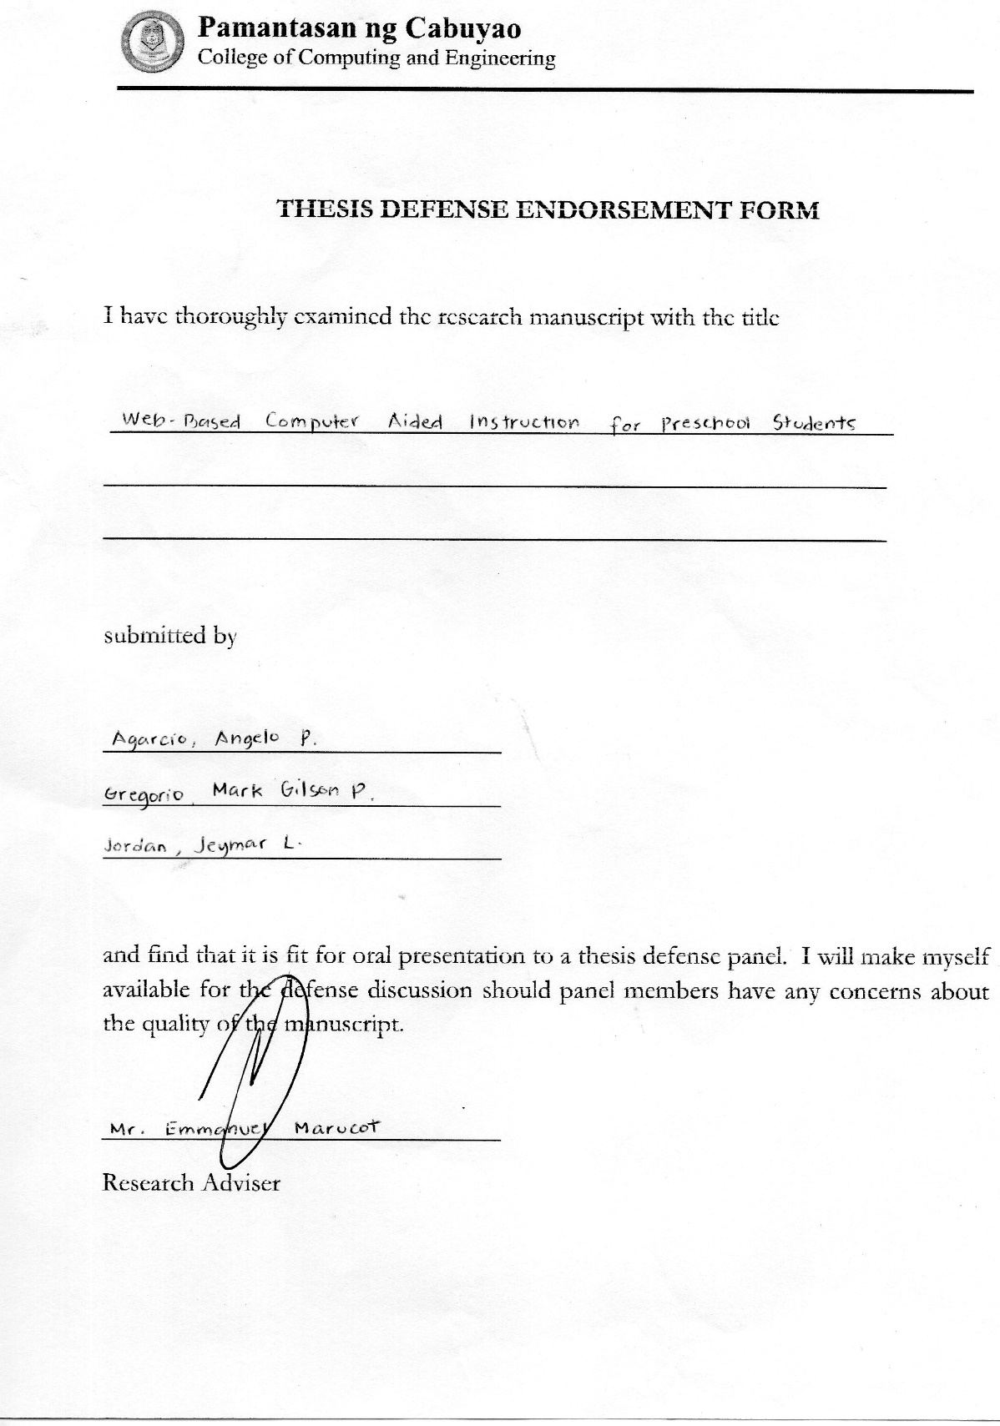

Language Editor Acceptance

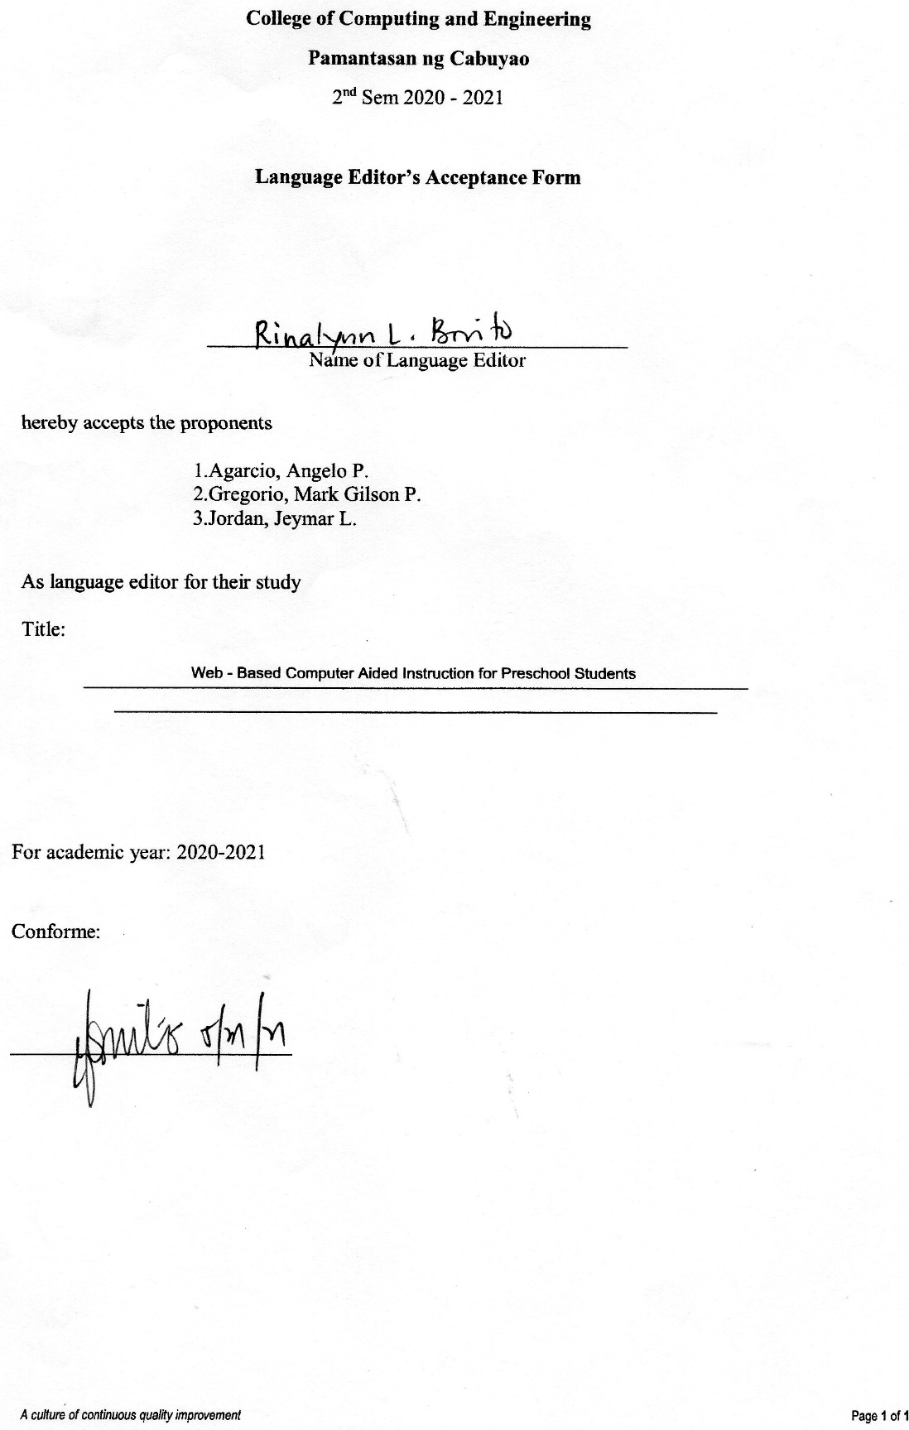

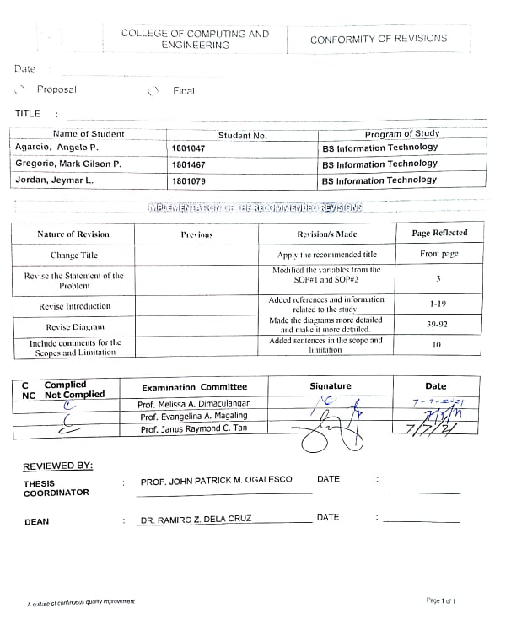Conformity of Revisions

**Online Computer Aided Instruction for Public Preschool Students**

**II Communication Letters**

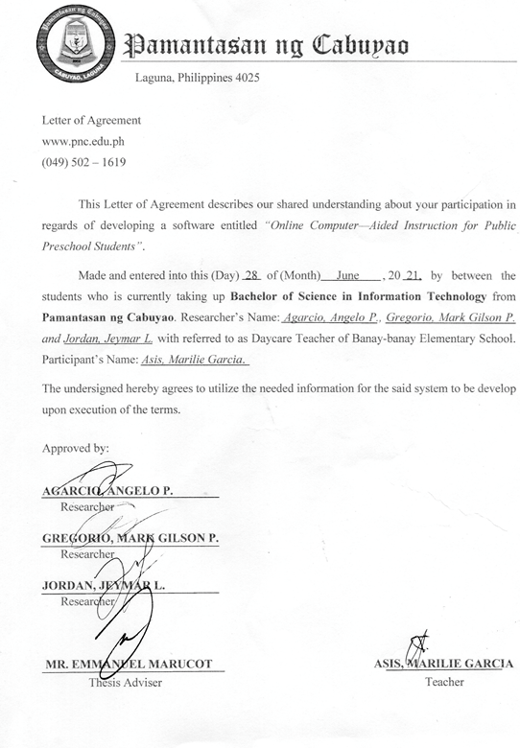Letter of Agreement

**III Data Gathering Activities**

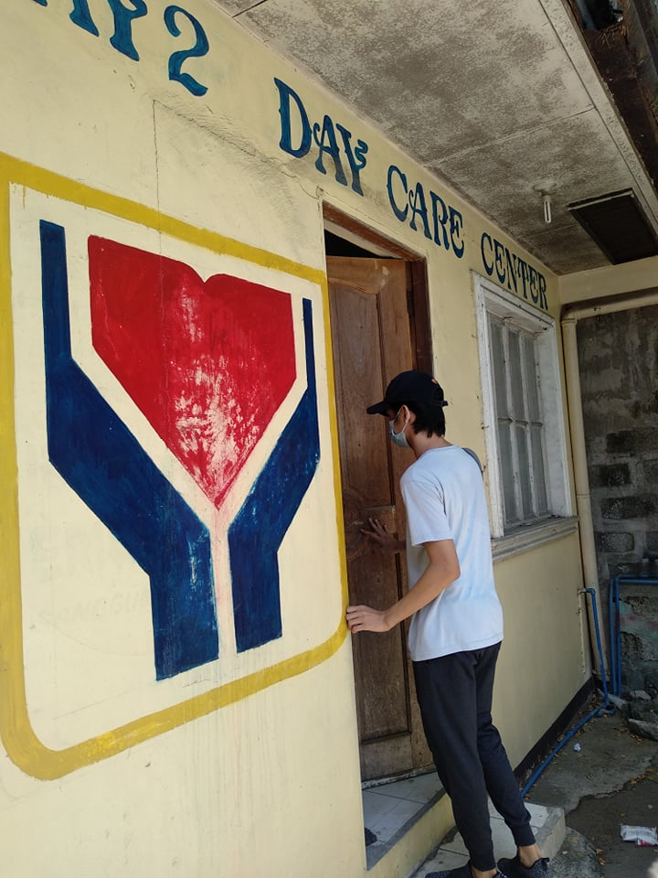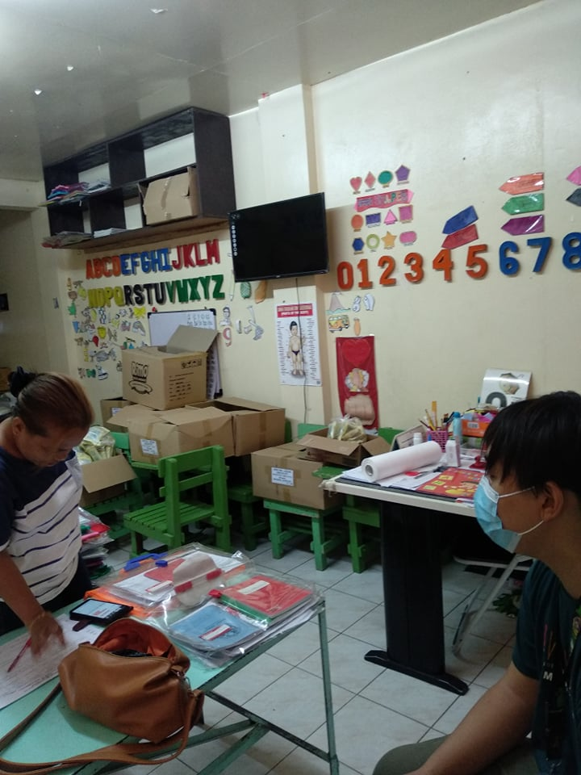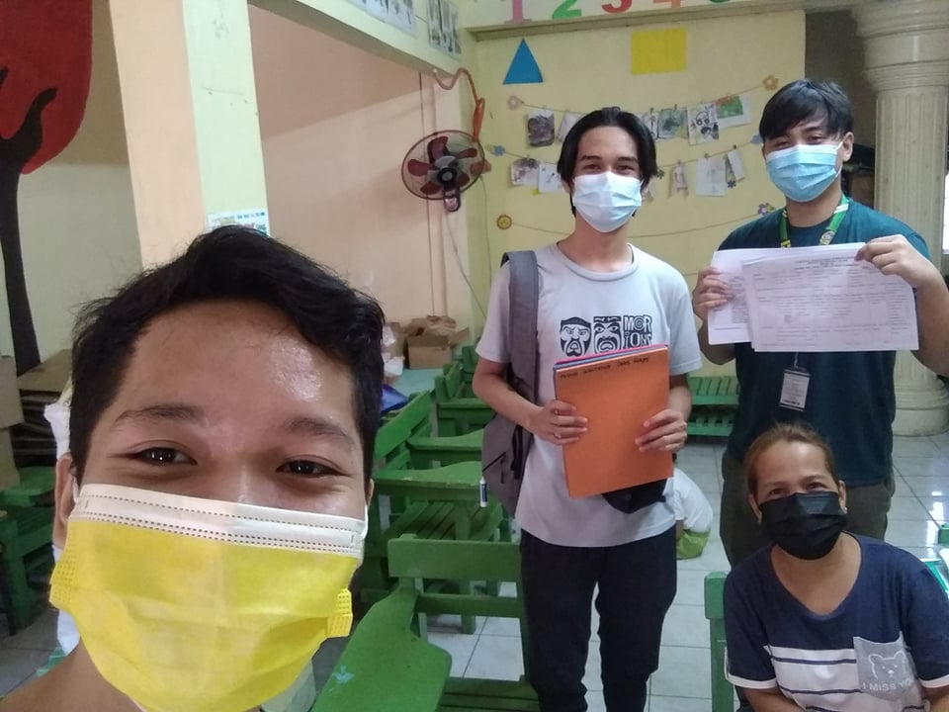

**IV Oral Defense**

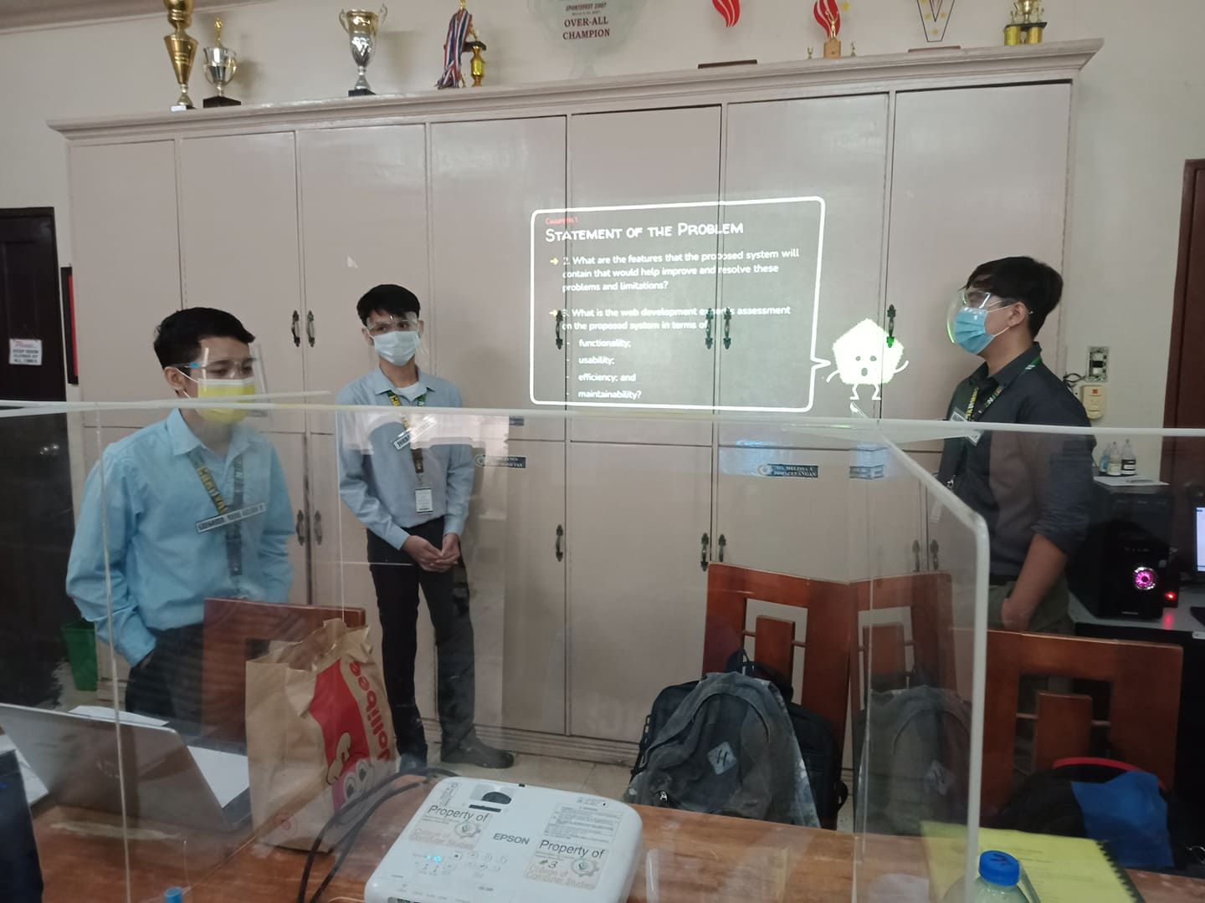

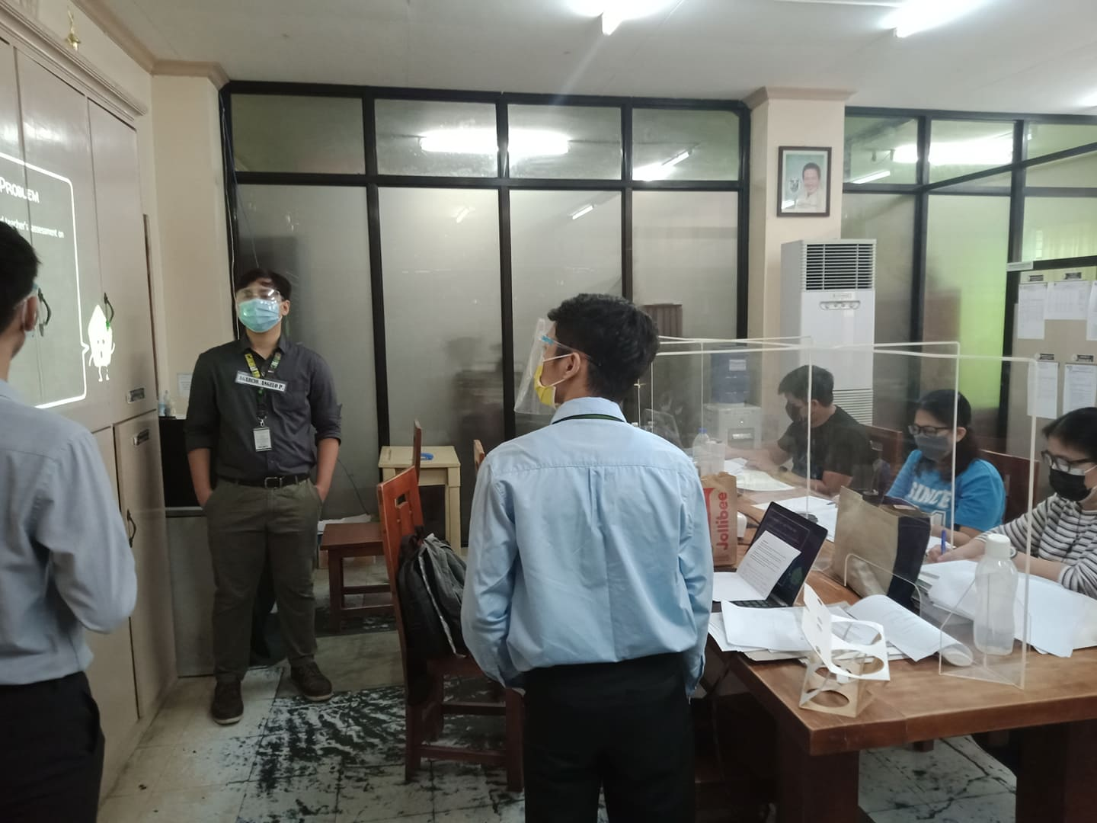

Even before the anticipated day of the defense, we rehearsed how we would defend our thesis in an informative and convincing way to our panelists. We optimized the PowerPoint presentation making it so that the balance between imagery and words are balanced enough that it would not clutter the presentation. On the day before the defense, we tried to anticipate some of the possible counter arguments to be thrown at us by the panel in order to answers them accordingly hoping to at least sway the panel's decision in the defense proper.

Then the day came and we immediately met up and did a quick dry run of what we would do during the defense with all the possible scenarios we could think have taken into account. And of course, as the time closes in for us to present, the nerves start to kick in. But as we start the presentation, the pressure we felt slowly dissipated and the tension slowly turned into excitement. We did our best to answer the questions and consider suggestions from the panel. And after a short deliberation amongst the panel, they were able to come to the conclusion that we passed. At this point we could not believe that we pulled it off but then again, it meant a lot for us because all of the efforts that we put into this thesis has payed off.

We, passing this defense was a huge stepping stone for us into a bigger hurdle in the next semester. We were ecstatic with us passing and the experiences that we gained from this important day and polish our mistakes in preparation for the defense of the developed system itself. We would have to work extra hard for the system to ensure that us passing is the right decision for the panel at that point in time.